National Respiratory Audit Programme (NRAP)
Approval to collect patient identifiable information without consent

Dear Caldicott Guardian,

The National Respiratory Audit Programme (NRAP) launched on 1 June 2023, continuing the delivery of asthma and COPD audits of primary care, secondary care, and pulmonary rehabilitation services as previously conducted under the National Asthma and COPD Audit Programme (NACAP).

Collection of patient identifiable information and Section 251 approval
The children and young people’s asthma audit collects patient identifiable information (NHS number, date of birth, postcode data, ethnicity, mental health status and date of death (if death occurred during admission)) to link with data from Hospital Episode Statistics (HES), Office for National Statistics (ONS) and Patient Episode Database for Wales, and report on patient outcomes.

Section 251 approval
This audit has Section 251 approval from the Health Research Authority Confidential Advisory Group (CAG). The CAG reference number is 19/CAG/001.

Next steps for Caldicott Guardians
Hospitals that admit children and young people with asthma will register to participate in the children and young people asthma audit. For their participation in this audit to fall within NHS information governance rules, we require your confirmation that all legal requirements for receiving and handling patient data (including identifiable and sensitive data) have been considered and will be complied with by your hospital.

- Please complete the form below and send it back to the NRAP team to confirm that your hospital has approval to participate in the children and young people asthma secondary care clinical audit.

- Once Caldicott Guardian approval has been received, your hospital will be granted access to the online audit data collection tool.

Access to this tool will not be granted, until receipt of this approval.

Submitting Caldicott Guardian approval
Please provide approval for your hospital. Approval must be given by completing the form below and submitting it to asthma@rcp.ac.uk.

Further information about the children and young people asthma audit and NRAP
Further information about the children and young people asthma audit and wider NRAP programme can be found here.

If you have any queries about the children and young people’s asthma audit, please contact the audit team at asthma@rcp.ac.uk or 020 3075 1526.

Thank you in advance for your support.

Yours faithfully,
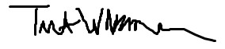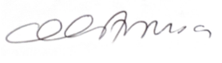
Professor Tom Wilkinson Lara Amusan
National Respiratory Audit Programme National Respiratory Audit Programme
Programme Clinical Lead Programme Manager

Caldicott Guardian Approval Form

We would be grateful if you could sign this form to confirm that you are happy that all legal requirements for receiving and handling patient data (including identifiable and sensitive data) have been considered and will be complied with by your hospital, and you are happy to support their participation in the NRAP children and young people asthma workstream.

Trust/Health Board
Hospital(s)
Name of Caldicott Guardian
Signature | 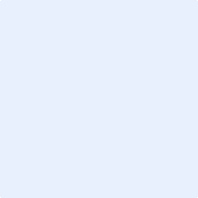
Date

