**Key points**

2020 and 2021 are pandemic years. 2019 is the pre-pandemic comparator. Therefore, for this report we will focus on 2019 vs 2021.

**FLS-DB key performance indicator (KPI)s**

1. Data completeness
2. Identification of all fragility fractures
3. Identification of spine fractures
4. Time to FLS assessment
5. Time to DXA
6. Bone therapy recommended
7. Falls assessment performed/ recommended / referred
8. Strength and balance training non-hip # patients only
9. Monitoring contact 12-16 weeks post fracture
10. Commenced bone therapy by 16 weeks post fracture
11. Adherent to a prescribed drug 12 months after fracture

**Patient level data**

1. There are three time intervals of data to be analysed (2019 and 2021 in the main (KPI 1-10); 2019 and 2020 for KPI 11)
   1. Interval a: Patients index fracture date from 1.1.2016 to 31.12.16
   2. Interval b: Patients index fracture date from 1.1.2017 to 31.12.17
   3. Interval c: Patients index fracture date in 1.1.2018 to 31.12.2018
   4. Interval d: Patients index fracture date in 1.1.2019 to 31.12.2019
   5. Interval e: Patients index fracture date in 1.1.2020 to 31.12.2020
   6. interval f: Patients index fracture date in 1.1.2021 to 31.12.2021
2. Key points to focus
   1. Increased engagement with FLS community (number of participating FLSs f vs d
   2. Number of records per site (interval d & f)
   3. Changes in data completeness using KPI 1-10
      1. Interval d vs f
   4. Delivery of KPI 11
      1. Interval d & e
   5. Diversity and equity (given gender and age differences in fracture incidence and site do not include KPI 2 and 3) and test for significance for non-normal data
      * 1. Men vs. Women for KPI 1,4,5,6,7,8,9,10,11
        2. Age <75 years and ≥75 years for KPI 9
        3. IMD ≤20% worst vs 80% highest IMD using postcode for KPI 1,2,3, 4,5,6,7,8,9,10,11
        4. Analyse care home status by gender, age, admission to hospital and site of first fracture and KPI 4, 5, 6, 7, 8, 9, 10, 11
3. Key data
4. Number of FLSs submitting any data in 2021
5. Number of FLSs actively participating > 50 patients in 2021
6. Total number of patients per site in 2021
7. For each KPI:

* National aggregate data - For all questions
* Between site data - For all questions

1. For each KPI stacked bar chart for number of orange and green sites for intervals d and f Figure 2 of 2021 report e.g:

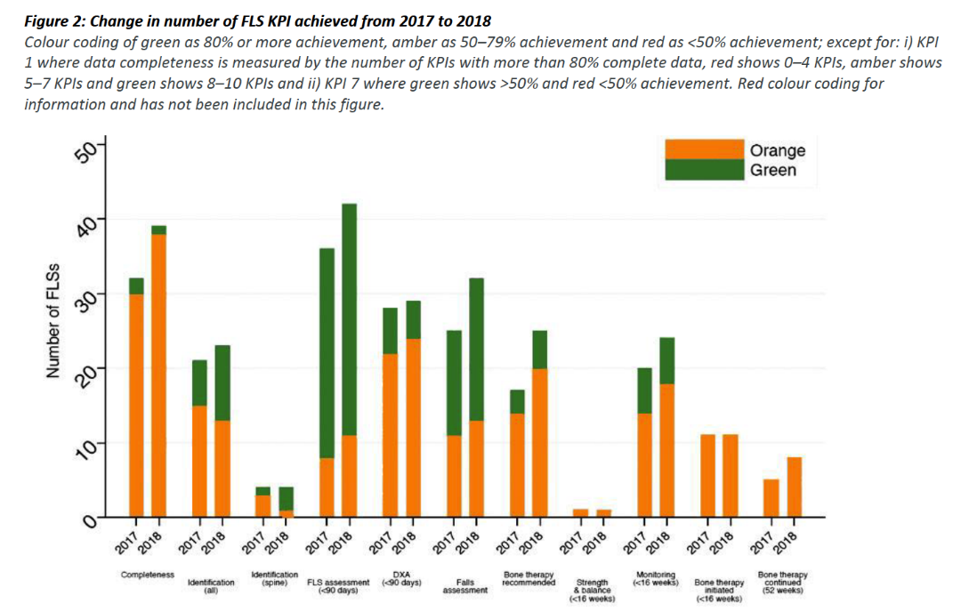

*Data cleaning notes*

1. Remove FLS site = “YYY” – test FLS site
2. Renaming FLS names
   1. Any records for “RBE” sitecode were given the FLS name of “West Berkshire FLS”
   2. Any records for “PET” sitecode were given the FLS name of “North West Anglia NHS Foundation”
   3. Records for “NMH”, “RFH” or “BEM” were given the FLS name “Enfield Bone Health and Fracture Liaison”
   4. Various FLS codes were inconsistent with codes using in the NHFD, so the following changes to FLS codes were made for sake of getting identification KPI:
   5. AIR -> RCF; AHX -> SPG; BRH -> BRO; BWA -> AEI; ESH -> CGH; CHN -> UHN; HAY -> STO; LLD -> UHW; OIC -> OHM; SFL -> SHH; SRH -> SLF; WWL -> AEI
3. Remove cases with ‘missing’ NHS number artemis code.
4. For duplicates –
   1. use the most recent complete record, i.e. combine duplicate records to use the most recent complete record that is not missing.
   2. The exception to this is duplicate post code- use original post code
   3. Flag if same artemis number, fracture date in more than one site. (e.g. Ealing / Northwick park, include FLS name and number of records
   4. Re-fractures by interval plot with same artemis number and fracture site with difference in fracture date is less than 7 days, include FLS name and number of records
   5. Flag if same artemis numbers but different fracture date (at least 7 days apart if same fracture site) to calculate number of re-fracture by FLS.
5. Exclude FLSs with less than 50 cases in interval e= report them as stars
6. Check for correct index fracture site order (hip is highest, then spine then non-hip / non-spine)
7. Check for duplicates in linked NHFD sites
8. Check for re-fractures in the same years as monitoring time points are fixed from first fracture of the year and not reset after a subsequent fracture in the same year.

**Facilities audit data**

Facilities audit data to inform clinical commentary (national figures) - percentage breakdown of the national sample for each response option eg 50/61 FLSs (82%) or average for the below questions:

1. Question 1.1
2. Question 1.4 (by year)
3. Question 1.5
4. Question 1.6 (average)
5. Question 1.7 (average WTE nurses and administrators only)
6. Question 1.8
7. Question 2.1 (average)
8. Question 2.2
9. Question 2.3
10. Question 2.3.1
11. Question 3.1
12. Question 3.2
13. Question 3.3
14. Question 3.4
15. Question 3.5
16. Question 3.6
17. Question 4.1
18. Question 4.2
19. Question 5.1
20. Question 5.2
21. Question 5.3
22. Question 6.1
23. Question 6.2
24. Question 6.2.1
25. Question 7.1
26. Question 7.2
27. Question 8.1
28. Question 8.2
29. Question 8.3
30. Question 9.1
31. Question 9.2
32. Question 9.3
33. Question 9.4
34. Question 10.1
35. Question 10.2
36. Question 10.3
37. Question 11

| **Indicator** | **Numerator** | **Denominator** | **Comment** |
| --- | --- | --- | --- |
| 1. Data completeness | Number of Key performance indicators 2-11 with more than 80% patients completeness | 10 (KPI 2-11) | 1. Calculate for interval d and f   * Missingness in KPI 2 describes missingness in fracture type in original data (after that, where type of fracture was missing, fragility was assumed). * For completeness stats of KPI 8 & 10, excluding any records not followed-up at 12-16 weeks * For completeness stats of KPI 11 excluding records not followed-up at 48-52 weeks  1. National average |
| 1. Identification | Total number of patients with fragility fracture submitted | Estimated fragility fracture caseload using annualised data from National Hip Fracture database (NHFD) x5 for that year. | 1. For interval d and f overall change in KPI:  a) average number of patients per FLS  b) average percentage of estimated caseload   1. For interval f: by site, Table 4:    * Numerator is number submitted from FLSDB    * Denominator per site is number of hip fractures submitted to NHFD in 2021 x5.    * Estimated caseload    * Percentage of estimated caseload submitted (all, <75 & >75yr)    * Plot figure. X axis is sorted by FLS volume in decreasing order. Y1 is total number cases submitted with black circle marker. Y2 is the proportion of first fractures divided into hip, non-hip, non spine, spine and missing as a stacked bar chart. See sample below    * total number of hip cases and % of hip cases compared with total number of cases submitted: (Table 4) 2. National average |
| 1. Spine fractures identified | Number of patients submitted with a spine fracture as primary fracture site | Number of Hip fractures using annualised data from National Hip Fracture database (NHFD) for that year | 1. Will include both clinical and radiological spine fractures  2. Table 1: Interval d vs f; by FLS   * Percentage of spine/ hip fractures submitted  1. National average |
| 1. Time to bone health assessment within 90 days | Number of patients with date of fracture – date of assessment = 90 days or less | Total number of patients submitted | 1.For interval d vs f: by FLS   * number submitted * number assessed within 90 days * % assessed within 90 days. (Table 5)   2. Need to table by FLS where the data of assessment is missing   1. Ratio of number of patients who Did Not Attend / total number of patients submitted by FLS for interval f 2. National average |
| 1. Time to DXA within 90 days | Number of patients with Date of DXA - Date of fracture = 90 days or less | Total number of patients submitted minus a) number where DXA already done; where a DXA was not ordered or where DXA status was missing | 1.For interval d vs f: by FLS   * number DXA recommended or ordered * number date of DXA within 90 days * % within 90 days. (Table 6) * Did not attend  1. For all patients combined and stratified by age < 75 years vs 75 years+ 2. National average |
| 1. Falls assessment | Number of patients with a falls assessment performed, recommended, referred for or already under falls service | Total number of patients submitted | 1.For interval d vs f: by FLS: table 7:   * Facilities question 6.1. How many perform a falls assessment * number and percentage for all patients / number submitted total all ages and stratified by age < 75 years vs 75 years+  1. National average |
| 1. Bone therapy recommended as appropriate | Number of patients with a treatment recommendation as specific bone therapy, refer for further clinical opinion, refer to GP to decide | Total number of patients submitted | 1. for interval d vs f by FLS table 8 for all ages and add column for missing (for all)  2. Subgroup of treatment options:   * + OralBP (alendronate , risedronte, ibandronate)   + Denosumab   + Zolendronate   + Raloxifene   + Teriparatide   + Referred to GP to decide prescription (called “referGP” in Excels)   + Referred for further clinical opinion (called “refer_opinion” in Excels)   2. for interval f, by FLS, table 9 for all subgroup by type of therapy, n & %.  If more than 1 drug submitted use this hierarchy: oral bisphosphonate > denosumab > zoledronate > > raloxifene > teriparatide > referGP, Refer_opinion   1. National average |
| 1. Strength and balance commenced | Number of non-hip non spine and spine fracture patients initiating a strength and balance class within 16 weeks of date of fracture | Number of patients with a bone therapy treatment recommendation or referred to GP or referred to other clinician minus patient dead where the fracture site is non-hip non-spine, spine | 1. For interval d vs f, by FLS for all ages and stratified by age < 75 years vs 75 years+  2. National average |
| 1. Recorded Follow-up 12 – 16 weeks post index fracture | Number of patients followed up post fracture = yes | Number of patients with a bone therapy treatment recommendation or referred to GP or referred to other clinician minus (patient dead and patient declined) | 1. for interval d vs f: columns for all fractures hip fracture vs. non-hip fracture, number eligible for monitoring all, hip, non-hip and then percentage monitored with FLS as rows (table 10)  2. Does not include calcium / Vitamin D only  3. National average |
| 1. Commenced bone therapy at 16 weeks | Number of patients commenced or continuing bone specific therapy within 16 weeks of date of fracture | Number of patients with a treatment recommendation or referred to GP or referred to other clinician minus (patient recorded as died and patient declined) | 1. for interval d vs f, by FLS n and %  2. National average  n.b. answers for 6.05 and 7.05 changed in 2020 to include treatment names from “Started recommended bone therapy” and “Switched recommended bone therapy” |
| 1. Did the patient confirm adherence to prescribed bone sparing drug at 12 months? | Number of patients continued taking recommended drug or switched drug at 12 months post fracture | Number of patients with a treatment recommendation or referred to GP or referred to another clinician minus (patient died and patient declined) | 1. for interval d vs f by FLS.  2. include non-contactable in the denominator  3. National average  n.b. answers for 6.05 and 7.05 changed in 2020 to include treatment names from “Started recommended bone therapy” and “Switched recommended bone therapy” |