
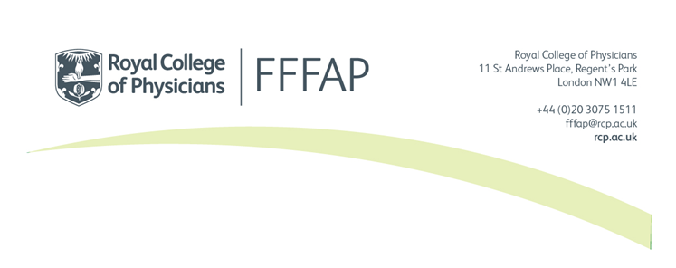
National Audit of Inpatient falls (NAIF)
Registration Form
To register to the continuous NAIF audit (as well as the facilities audit), please return your completed registration form to falls@rcp.ac.uk.

Trust/Health board name:
ODS code:  (aka NACS) |  | Type of service  (Tick all that apply) | ☐ Acute  ☐ Specialist  ☐ Community  ☐ Mental health
Street: |  | Town:
Postcode: |  | Region: Choose an item.
Phone number (landline):

User registration
The people below have agreed to be the ‘lead clinician’ and ‘data inputter(s)’ for this audit and are happy to be contacted about the audit using the provided email and/or telephone. The Lead Clinician is responsible for ensuring the data entered into the audit is correct and should read the guidance on their registration responsibilities.
Lead clinician
First name: | Surname:
Job title: | Job type: Choose an item.
Phone number (landline): | Extension (if applicable):
Email address: | Mobile (optional):

Data inputter
First name: | Surname:
Job title: | Job type: Choose an item.
Phone number (landline): | Extension (if applicable):
Email address: | Mobile (optional):

Data inputter
First name: | Surname:
Job title: | Job type: Choose an item.
Phone number (landline): | Extension (if applicable):
Email address: | Mobile (optional):
The Caldicott Guardian for your trust/Health board must approve on this registration by signing below:
Caldicott guardian
Full name: | Email Address:
Signature: | Date:

Once complete, please send this form to the NAIF team – falls@rcp.ac.uk
If you require more users than the space above allows, please also include their details in the email along with the form.

