 | Insert Trust branding here
NHS: «NHS»  Date: «Date of assessment»  «Prefix» «FirstName» «LastName»  «Address1»  «Address2»  «Address3»  «Address4»  «Address5»  «Postcode» | FLS name  «Address1»  «Address2»  «Address3»  <<Postcode>>  Tel: <<Telephone>>  Fax: << Fax>>  Email: <email@nhs.net>>

Dear «Prefix» «LastName»,
You were recently «seen/identified by» by specialist nurse «SeenBy» from the fracture liaison service (FLS) after you fractured your «Fracture1». The assessment you were given suggests that you may have osteoporosis, a condition that causes bones to become weaker. According to your results:

Your risk of another fracture is: | Low |  | High | Or «FraxScoreMa»
With treatment this could be reduced to: | Low |  | High

Next steps
- For more information about reducing your risk of future fractures please see overleaf.
- We have discussed your prescription, which should be available after <<insert relevant interval in days or local protocol with regards to prescription>>. Your GP has been asked to continue this prescription. If you wish to discuss this with your GP practice as well, please make an appointment with a healthcare professional at your GP practice and have this letter to hand.
- We will contact you in 3 months to see how you are.

Who to contact if you have further questions
- Your GP or community pharmacist – especially if you have questions about your medication
- The Royal Osteoporosis Society: 08008 800 0035 or www.theros.org.uk
- Your FLS team (contact details on the top of the page).

Signed: «Seenby»
What can you do to reduce your fracture risk?
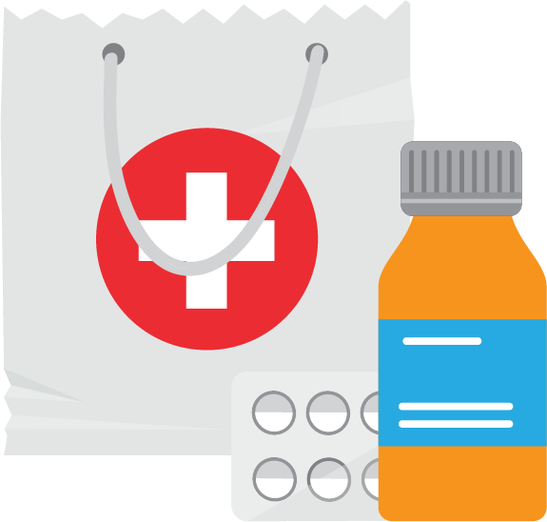 | Medication  «information on treatment, frequency, method of administration  and duration, or if declined»
 | You need calcium to make sure your medication works to strengthen your bones. «information about the patients calcium levels and advice» Find out if you are getting enough calcium: https://theros.org.uk/calcium-foods
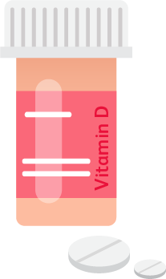 | Vitamin D is needed for your medication to work to  strengthen your bones.  «information about the patients Vitamin D levels and advice»
 | Reducing your risk of falls  «information on falls service and whether required»
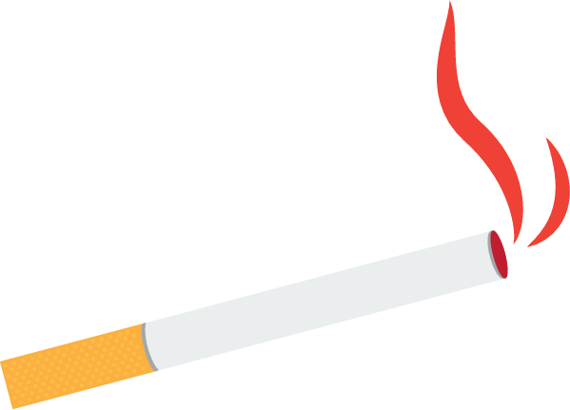 | Avoid smoking  «information on whether patient smokes and advice»
 | Reduce alcohol intake  «information on patients alcohol intake and advice»

Further advice lifestyle advice available on:
www.rcplondon.ac.uk/FLS-patient-info and www.theros.org.uk

