**Key points**

This report will focus on 2022 vs 2023 date of fracture data for England and Wales only. Analysis is not required for Northern Ireland patient records, no facilities audit in 2024.

**FLS-DB key performance indicator (KPI)s**

1. Data completeness
2. Identification of non-spine fragility fractures
3. Identification of spine fractures
4. Time to FLS assessment
5. Time to DXA
6. Bone therapy recommended
7. Falls assessment performed/ recommended / referred
8. Strength and balance training non-hip # patients only
9. Monitoring contact 12-16 weeks post fracture
10. Commenced bone therapy by 16 weeks post fracture
11. Adherent to a prescribed drug 12 months after fracture

**Patient level data**

1. There are three-time intervals of data to be analysed based on the fracture date (2022 and 2023 in the main (KPI 1-10); 2021 and 2022 for KPI 11), highlighted below:
   1. Interval a: Patients index fracture date from 1.1.2016 to 31.12.16
   2. Interval b: Patients index fracture date from 1.1.2017 to 31.12.17
   3. Interval c: Patients index fracture date in 1.1.2018 to 31.12.2018
   4. Interval d: Patients index fracture date in 1.1.2019 to 31.12.2019
   5. Interval e: Patients index fracture date in 1.1.2020 to 31.12.2020
   6. interval f: Patients index fracture date in 1.1.2021 to 31.12.2021
   7. interval g: Patients index fracture date in 1.1.2022 to 31.12.2022
   8. interval h: Patients index fracture date in 1.1.2023 to 31.12.2023
2. Key points to focus
   1. Increased engagement with FLS community (number of participating FLSs h vs g)
   2. Number of records per site (interval h & g)
   3. Changes in data completeness using KPI 1-10
      1. Interval h vs g
   4. Delivery of KPI 11
      1. Interval f & g
   5. Diversity and equity (given gender and age differences in fracture incidence and site do not include KPI 2 and 3) and test for significance for non-normal data (interval h & g)
      * 1. Men vs. Women for KPI 5,6, 7,9,10,11
        2. Age <75 years and ≥75 years for KPI 5,6, 7,9,10,11
        3. IMD ≤20% worst vs 80% highest IMD using postcode for KPI 1,2,3, 4,5,6,7,8,9,10,11
        4. Analyse care home status by gender, age, admission to hospital and site of first fracture and KPI 5, 6, 7, 8, 9, 10, 11
   6. Summary KPI 1 -10 for intervals h vs g for England and Wales separately
   7. Summary for KPI 11 for intervals f vs g for England and Wales separately
3. Key data
4. Number of FLSs submitting any data in 2023
5. Number of FLSs actively participating > 50 patients in 2023
6. Total number of patients per site in 2023
7. For each KPI:

* National aggregate data - For all questions
* Between site data - For all questions

1. Create file which would be uses to create the original orange and green graph (outlined below) for RCP to be able to create a different infographic on the same data.

*For reference (NOT NEEDED): For each KPI stacked bar chart for number of orange and green sites for intervals f and g Figure 2 of 2021 report e.g:*

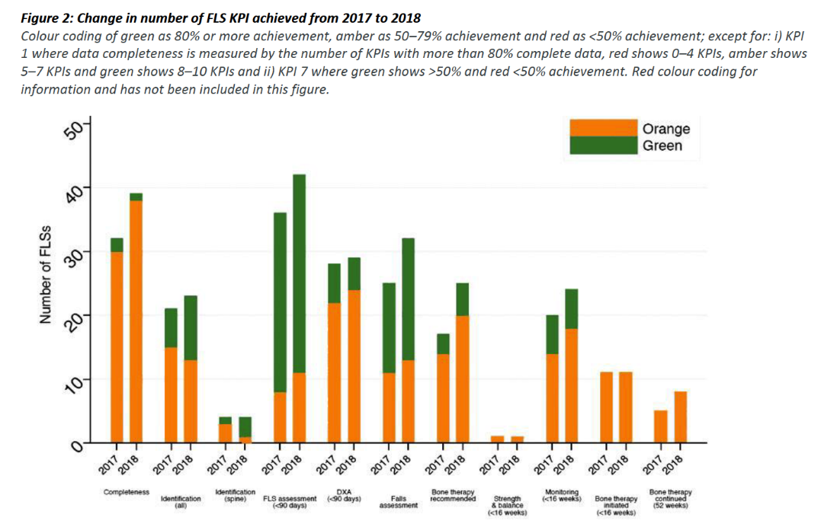

*Data cleaning notes*

1. Remove FLS site = “YYY” – test FLS site
2. Renaming FLS names
   1. FLS project team to confirm what NHFD site(s) the participating FLSs cover from facilities audit and new registrations in the year data being analysed.
   2. Any records for “RBE” sitecode were given the FLS name of “West Berkshire FLS”
   3. Any records for “PET” sitecode were given the FLS name of “North West Anglia NHS Foundation”
   4. Records for “NMH”, “RFH” or “BEM” were given the FLS name “Enfield Bone Health and Fracture Liaison” “BEM”
   5. Records for “DAR” or “DRY” were given the FLS name “UNIVERSITY HOSPITAL NORTH DURHAM DARLINGTON MEMORIAL HOSPITAL” “DAR”
   6. Records for “WHH”, “QEQ” or “KCC” were given FLS name “East Kent Hospital University NHS Trust” “KCC”
   7. Be aware NORTHERN CARE ALLIANCE - BURY COMMUNITY SERVICES (NCA) and PENNINE MUSCULOSKELETAL PARTNERSHIP LTD (OIC) see patients from OHM; NORTHERN CARE ALLIANCE - BURY COMMUNITY SERVICES (NCA) also sees patients from NMG
   8. Records for “NOC”, “RAD” or “HOR” were given FLS name “OXFORDSHIRE FRACTURE PREVENTION SERVICE” “RAD”
   9. Various FLS codes were inconsistent with codes using in the NHFD, so the following changes to FLS codes were made for sake of getting identification KPI:

AHX -> SPG; BRH -> BRO; BWA -> AEI; CHN -> UHN; ESH -> CGH; HAY-> STO; LLD -> UHW; OIC -> OHM; RCF -> AIR; SFL -> SHH; SRH -> SLF; WWL -> AEI

1. Remove cases with ‘missing’ NHS number artemis code.
2. Check for correct index fracture site order (hip is highest, then spine then non-hip / non-spine)
3. Exclude FLSs with less than 50 cases in interval h= report them as non-participating
4. For duplicates records with same artemis number –
   1. use the most recent complete record, i.e. combine duplicate records to use the most recent complete record that is not missing.
   2. The exception to this is duplicate post code- use original post code
   3. Report if same artemis number and *same fracture date* frommore than one FLS site. (e.g. Ealing / Northwick park, include FLS name and number of records, and FLS sites)
   4. Report if same artemis number and *different fracture date* less than 7 days, include FLS name and number of records and FLS site
   5. Report if same artemis numbers but different fracture date 7 days or more apart) to calculate number of re-fracture by FLS by FLS site, include FLS name, initial and subsequent fracture site and number of records by FLS site
5. Check for duplicates in linked NHFD sites
6. Check for re-fractures in the same years as monitoring time points are fixed from first fracture of the year and not reset after a subsequent fracture in the same year.

| **Indicator** | **Numerator** | **Denominator** | **Comment** |
| --- | --- | --- | --- |
| 1. Data completeness | Number of Key performance indicators 2-11 with more than 80% patients completeness | 10 (KPI 2-11) | 1. Calculate for *interval g and h*   * Missingness in KPI 2 describes missingness in fracture type in original data (after that, where type of fracture was missing, fragility was assumed). * For completeness stats of KPI 8 & 10, excluding any records not followed-up at 12-16 weeks * For completeness stats of KPI 11 excluding records not followed-up at 48-52 weeks  1. National average |
| 1. Identification of non-spine fractures (excluding spine fractures) | Total number of patients with fragility fracture submitted, excluding spine fractures | Estimated fragility fracture caseload using annualised data from National Hip Fracture database (NHFD) x4 for that year * 0.94 as an additional addition of a multiplier to take into account the NDO effect of 6% opt-out | 1. For *interval g and h* overall change in KPI:  a) average number of patients per FLS  b) average percentage of estimated caseload   1. For *interval h*: by site, Table 4:    * Plot figure below. X axis is sorted by FLS volume in decreasing order of non-spine fractures submitted. Y1 is total number cases submitted with black circle marker. Y2 is the proportion of first fractures divided into hip, non-hip, non spine, spine as a stacked bar chart. See sample below    * total number of hip cases and % of hip cases compared with total number of cases submitted: (Table 4) 2. National average |
| 1. Spine fractures identified | Number of patients submitted with a spine fracture as primary fracture site | Number of Hip fractures using annualised data from National Hip Fracture database (NHFD) for that year * 0.94 as an additional addition of a multiplier to take into account the NDO effect of 6% opt-out | 1. Will include both clinical and radiological spine fractures  2. Table 1: Interval g vs h; by FLS   * Percentage of spine/ hip fractures submitted * National average |
| 1. Time to bone health assessment within 90 days | Number of patients with date of fracture – date of assessment = 90 days or less | Total number of patients submitted | 1.For *interval g vs h*: by FLS   * number submitted * number assessed within 90 days * % assessed within 90 days. (Table 5)   2. Need to table by FLS where the data of assessment is missing   1. Ratio of number of patients who Did Not Attend / total number of patients submitted by FLS for interval g 2. National average |
| 1. Time to DXA within 90 days | Number of patients with Date of DXA - Date of fracture = 90 days or less | Total number of patients submitted minus a) number where DXA already done; where a DXA was not ordered or where DXA status was missing | 1.For *interval g vs h*: by FLS   * number DXA recommended or ordered * number date of DXA within 90 days * % within 90 days. (Table 6) * Did not attend  1. For all patients combined and stratified by age < 75 years vs 75 years+ 2. National average |
| 1. Falls assessment | Number of patients with a falls assessment performed, recommended, referred for or already under falls service | Total number of patients submitted | 1.For interval g vs h: by FLS: table 7:   * Facilities question 6.1. How many perform a falls assessment * number and percentage for all patients / number submitted total all ages and stratified by age < 75 years vs 75 years+  1. National average |
| 1. Bone therapy recommended as appropriate | Number of patients with a treatment recommendation as specific bone therapy, refer for further clinical opinion, refer to GP to decide | Total number of patients submitted | 1. for interval g vs h by FLS table 8 for all ages and add column for missing (for all)  2. Subgroup of treatment options:   * + OralBP (alendronate , risedronte, ibandronate)   + Denosumab   + Zolendronate   + Raloxifene   + Teriparatide   + Referred to GP to decide prescription (called “referGP” in Excels)   + Referred for further clinical opinion (called “refer_opinion” in Excels)   2. for interval g, by FLS, table 9 for all subgroup by type of therapy, n & %.  If more than 1 drug submitted use this hierarchy: oral bisphosphonate > denosumab > zoledronate > > raloxifene > teriparatide > referGP, Refer_opinion   1. National average |
| 1. Strength and balance commenced | Number of non-hip fracture patients initiating a strength and balance class within 16 weeks of date of fracture | Number of patients with a bone therapy treatment recommendation or referred to GP or referred to other clinician minus patient dead where the fracture site is non-hip | 1. For interval g vs h, by FLS for all ages and stratified by age < 75 years vs 75 years+  2. National average |
| 1. Recorded Follow-up 12 – 16 weeks post index fracture | Number of patients followed up post fracture = yes & follow up is less than 16 weeks post fracture diagnosis date. | Number of patients with a bone therapy treatment recommendation or referred to GP or referred to other clinician minus (patient dead and patient declined) | 1. for interval g vs h: columns for all fractures hip fracture vs. non-hip fracture, number eligible for monitoring all, hip, non-hip and then percentage monitored with FLS as rows (table 10)  2. Does not include calcium / Vitamin D only  3. National average |
| 1. Commenced bone therapy at 16 weeks | Number of patients commenced or continuing bone specific therapy within 16 weeks of date of fracture | Number of patients with a treatment recommendation or referred to GP or referred to other clinician minus (patient recorded as died and patient declined) | 1. for interval g vs h, by FLS n and %  2. National average  n.b. answers for 6.05 and 7.05 changed in 2020 to include treatment names from “Started recommended bone therapy” and “Switched recommended bone therapy” |
| 1. Did the patient confirm adherence to prescribed bone sparing drug at 12 months? | Number of patients continued taking recommended drug or switched drug at 12 months post fracture | Number of patients with a treatment recommendation or referred to GP or referred to another clinician minus (patient died and patient declined) | 1. for interval f vs g by FLS.  2. include non-contactable in the denominator  3. National average  n.b. answers for 6.05 and 7.05 changed in 2020 to include treatment names from “Started recommended bone therapy” and “Switched recommended bone therapy” |